CSE 425

Studio 1

1. Chris Ogle; Seed Zeng
2. Studio 1
3. it outputs Hello, World !
4. 

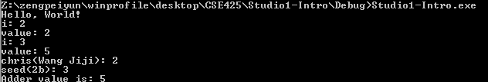

6.